Editors' Suggestion

PHYSICAL REVIEW LETTERS 129, 237402 (2022)

Electric Field-Controlled Damping Switches of Coupled Dirac Plasmons

Huayang Zhang [,](https://orcid.org/0000-0003-0587-0235)1,2,3,¶ Xiaodong Fan [,](https://orcid.org/0000-0001-7332-563X)1,2,3,*,¶ Dongli Wang,1,2,3 Dongbo Zhang,1,2,3 Xiaoguang Li [,](https://orcid.org/0000-0001-9979-053X)4,† and Changgan Zeng1,2,3,‡

1*CAS Key Laboratory of Strongly-Coupled Quantum Matter Physics, and Department of Physics,*

*University of Science and Technology of China, Hefei, Anhui 230026, China* 2*International Center for Quantum Design of Functional Materials (ICQD), Hefei National Research Center for Physical Sciences at the Microscale, University of Science and Technology of China, Hefei, Anhui 230026, China*

3*Hefei National Laboratory, University of Science and Technology of China, Hefei, Anhui 230088, China*

4*Institute for Advanced Study, Shenzhen University, Shenzhen, Guangdong 518060, China*

(Received 25 June 2022; accepted 2 November 2022; published 30 November 2022)



For quasiparticle systems, the control of the quasiparticle lifetime is an important goal, determining whether the related fascinating physics can be revealed in fundamental research and utilized in practical applications. Here, we use double-layer graphene with a boron nitride spacer as a model system to demonstrate that the lifetime of coupled Dirac plasmons can be remotely tuned by electric field-controlled damping pathways. Essentially, one of the graphene layers serves as an external damping amplifier whose efficiency can be controlled by the corresponding doping level. Through this damping switch, the damping rate of the plasmon can be actively tuned up to 1.7 fold. This Letter provides a prototype design to actively control the lifetime of graphene plasmons and also broadens our horizon for the damping control of other quasiparticle systems.

DOI: [10.1103/PhysRevLett.129.237402](https://doi.org/10.1103/PhysRevLett.129.237402)

Lifetime is a key quantity for quasiparticles such as

excitations or hybrid moire´

superlattice bands, can the

exciton, plasmon, and phonon polariton, in their surround- ings. A proper lifetime is a precondition for the various unique properties and potential applications related to those excitations, such as plasmonic metamaterial [1,2], exciton Bose-Einstein condensation [3,4], and nanoacoustic reso- nator [5,6]. Once the research objective is established, the lifetime is generally perceived as an intrinsic property. Thus many previous studies had sought to understand the damping mechanisms or search for systems with intrinsic optimal lifetime [7](#_bookmark16)–[11]. However, another possible appro- ach is to actively harness the lifetime by adding an exter- nally steerable modulator, analogous to the Purcell effect. This would provide a convenient handle that could be easily attached to various quasiparticle switching devices. Nevertheless, related experimental and theoretical attempts are rare.

The plasmon of graphene, originating from its Dirac electron gas, possesses many intriguing properties such as strong localization and low consumption [12](#_bookmark18)–[14]. More intriguingly, the properties of the Dirac plasmon, such as resonance frequency and strength, are closely related to the Fermi energy of the graphene, which can be effectively controlled by a bias voltage [15](#_bookmark20)–[17]. However, the plasmon lifetime is almost at a constant level when the carrier density is varied in an established graphene device [15,18,19]. Only in specific hybrid systems, in which the graphene plasmon interacts with intrasystem phonon

plasmon lifetime be tuned by locally adjusting the Fermi level [20,21]. Thus, a universal approach for manipulating the graphene plasmon lifetime is still lacking.

Here, we fabricated graphene/BN/graphene heterostruc- tures to investigate the properties of coupled Dirac plas- mons and explore ways to actively control plasmon lifetime. Through separate control of the Fermi energies of the two graphene layers, we achieved wide-range adjustment of plasmon intensity and wavelength. More importantly, we demonstrate that by using the tunability of the additional damping pathways, the lifetime of the coupled Dirac plasmons can be effectively controlled by the bias voltage. Essentially, one of the graphene layers acts as a damping amplifier. Compared with previous studies [20,21], this damping amplifier is external and tolerant to various excitation energies, which makes it more flexible in device design and transferable for lifetime control in other quasiparticle systems.

The graphene/BN/graphene heterostructure supports coupled plasmon modes arising from long-range inter- layer Coulomb interactions [22](#_bookmark27)–[24]. The dispersions of the coupled plasmons developed from two single-layer gra- phene plasmons have two branches, called the optical mode and the acoustic mode, representing in-phase and out- of-phase charge oscillations, respectively, as shown in Fig. 1(a). Figure 1(b) shows the schematic layout of the heterostructure, which was produced by the conventional

0031-9007*=*22*=*129(23)*=*237402(6) 237402-1 © 2022 American Physical Society

(a)

+ + + - - -

+ + + - - -

Optical mode

Acoustic mode

+ + + - - -

- - - + + +

*ω*

(c)

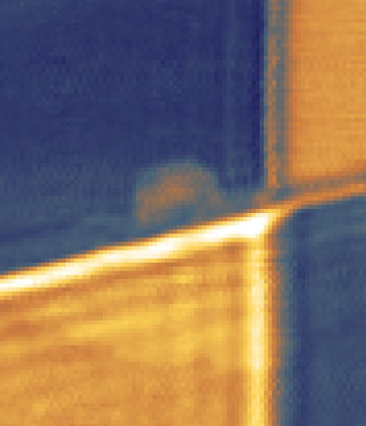

|  |  |  |
| --- | --- | --- |
| Top layer | | *h*-BN |
|  |  | Bottom layer |
| Coupled region | |  |

*q*

1.3

*S*/*Sh*-BN *S*/*Sh*-BN

0.4

(d)

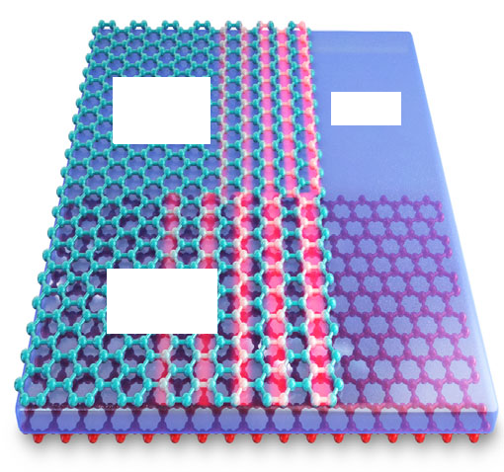

(b)

Single layer

*h*-BN

Coupled region

1.2

*λ*c = 209.8 nm

Coupled region

*λ*s = 126.3 nm

Single layer

1.0

0.8

0.6

0 200

400

*x* (nm)

600

800

is gradually increased by varying *V*BG. A substantial rise of wavelength and intensity of the coupled plasmons is evident in both the near-field images and the corresponding line profiles [Fig. 2(g)]. Meanwhile, the plasmons in single- layer region also alter obviously as *ns* (the carrier density of the single-layer region) is also modified by *V*BG. For comparison, we record the plasmon wavelength and inten- sity for both the coupled and single-layer regions in the same gating voltage range, and show the results in Fig. 2(h). Distinctly, the tuning ranges for both the intensity and wavelength of the coupled plasmons are much larger than those of the single-layer graphene plasmon: 4.0 times larger in terms of wavelength and 2.1 times larger in terms of intensity. Moreover, a more comprehensive mapping between the wavelength and both *nt* and *nb* is shown in Fig. 2(i) (see also in Fig. S2 of the Supplemental Material [25]), which demonstrates an even wider tuning range of plasmon wavelength. Turning to the lifetime, we note a special case where *nb* ≈ 0 with the Fermi level of the bottom-layer graphene near the Dirac point as shown in

FIG. 1. Coupled plasmon modes in the separated double-layer graphene system. (a) Simplified dispersions of coupled and single-layer plasmon modes. (b) Sketch of the layered hetero- structure with top graphene (green), interlayer *h*-BN (blue), and bottom graphene (red). (c) Plasmon fringes in the graphene/BN (3 nm)/graphene heterostructure detected by scanning near-field microscopy. The edge of the top-layer graphene is marked by a white dashed line. Scale bar, 200 nm. (d) Plasmon line profiles extracted from (c) along the dashed lines.

van der Waals assembly technique (see Sec. I of the Supplemental Material [25]). Scattering-type scanning near-field optical microscopy with an excitation light at λ 10.695 μm was utilized to image the plasmon fringes [15,16]. Figure 1(c) shows a typical near-field image, where four distinct regions including a single-layer plas- mon region (upper left) and coupled plasmon region (left lower) can be clearly seen. The absolute carrier densities are 7.3 × 1012 cm−2 for the top-layer graphene and 1.5 × 1013 cm−2 for the bottom-layer graphene in the coupled region. The plasmon wavelength is obtained from the corresponding line profiles shown in Fig. 1(d). The wave- length of the single-layer plasmon is 126.3 nm, consistent with a previous report [18], while the observed coupled mode, exhibiting a much longer wavelength, can be identified as the optical mode shown in Fig. 1(a).

¼

The dual-gate arrangement shown in Fig. 2(a) allows us to separately control the carrier densities of the top and bottom graphene layers (see Fig. S1 in the Supplemental Material [25]). This flexibility is also reflected by the wide- range tunability of the intensity, wavelength, and even the lifetime of coupled plasmons. In the near-field images in Figs. 2(c)–2(f), the carrier density of the top-layer graphene in the coupled region (*nt*) is fixed at −9.8 × 1012 cm−2 (*V*int ¼ 3 V), while that of the bottom-layer graphene (*nb*)

Fig. 2(c). In this case, as *ns* is similar to *nt*, the obtained plasmon wavelength and intensity of the coupled region are almost the same as those in the single-layer region. Nevertheless, the propagation length of the coupled plas- mon is obviously much shorter than that of the single-layer plasmon, which indicates strong damping for the coupled plasmon when *nb* is nearly 0.

To better understand the coupled plasmons, we inves- tigated the system theoretically by using linear response theory within the mean-field random-phase approximation [22,26,27,37]. Figure 3(a) shows the dispersion of the coupled plasmon, which is divided into three distinct regions by the *h*-BN phonon bands (orange shaded regions) [18,20,38]. Since the excitation energy is 115.9 meV [red dashed line in Fig. 3(a)], we mainly focus on the middle part between the two phonon bands. For comparison, the dispersion of the single-layer graphene plasmon is also shown as the black curve, with the calculated optical and acoustic modes located on the left and right sides, respec- tively. Since the acoustic mode has a very weak intensity, the observed plasmon fringes are mainly attributed to the optical mode. This assumption is also supported by an excellent agreement between the experimental and theo- retical results of the carrier density dependence of the plasmon wavelength, as shown in Fig. 3(b). In addition to the wavelength, the experimentally obtained intensities of the plasmon are also shown in Fig. 3(b) as the color depth of the red dots, whose variation tendency also agrees well with the theoretical results.

The experimental lifetime of the plasmon can also be

obtained by fitting the plasmon line profiles (see Fig. S3 in the Supplemental Material [25]). The extracted damp- ing rate γ*c* is shown in Fig. 3(c) as black dots. For the fixed *nt* −9.8 × 1012 cm−2, we find that when *nb >* 5.0× 1012 cm−2, γ*c* is nearly constant, which is similar to the

¼

(g)

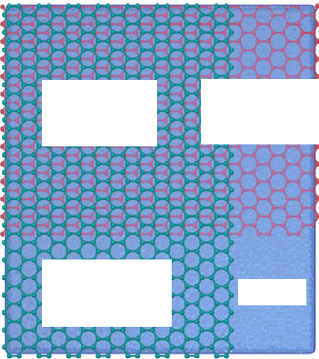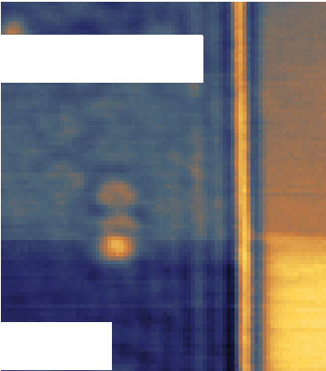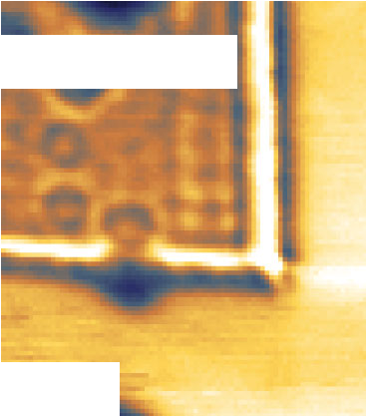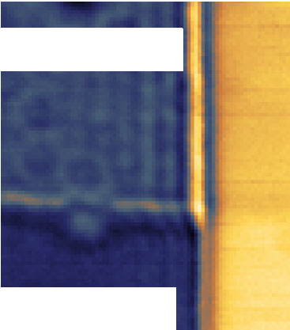

(c)

*n*b= -0.03 *n*t

*n*s ≈ *n*t

(a)

tip

*ћω*

(b)

Coupled Bottom

*h*-BN region graphene

1.1

*V*int *h*-BN

*n*s *n*t

*n*b

*V*BG *h*-BN

graphite

Top graphene

*h*-BN

0.4

(f)

*n*b = -1.23 *n*t

*n*s ≈ 0

(e)

*n*b = -0.59 *n*t

*n*s = 0.52 *n*t

(h)

250

(c) Single layer

*λ*s =137.3 nm

Coupled

(c)

region

*λ*c =137.6 nm

(d)

*λ*c =146.7 nm

(e)

*λ*c =167.9 nm

(f)

*λ*c =211.2 nm

*n*b

200

*λ* (nm)

150

100

1. 18 16 14 12 10 8 6 4 2

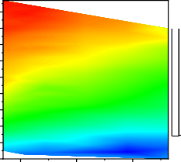

*S*/*Sh*-BN *S*/*Sh*-BN

*n*b (1012 cm-2)

*n*b (1012 cm-2)

0 4 8 12 16

Coupled region

Single layer

1.2

*S*1/*Sh*-BN

1.0

0.8

0 4 8 12 16

*|n*s| (1012 cm-2)

247.5

*λ*c (nm)

114.0

*n*t = -9.8×1012 cm-2 for coupled region of all images

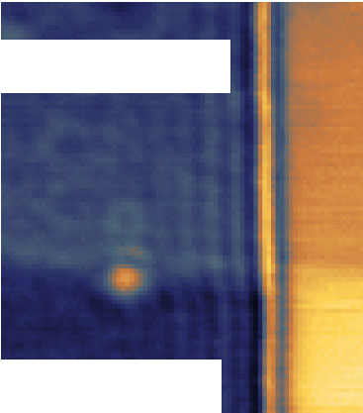

(d)

*n*b = -0.28 *n*t

*n*s = 0.78 *n*t

0 200 400

*x* (nm)

0 -10.0 -9.0 -8.0

*n*t (1012 cm-2)

FIG. 2. Carrier density dependence of the coupled plasmons. (a) Side-view schematic of the dual-gate double-layer graphene device.

1. Plane schematic of the double-layer graphene device, including four regions: coupled region, top-layer graphene, bottom-layer graphene, and *h*-BN. (c)–(f) Near-field images of the double-layer system (with an *h*-BN spacer of 6.8 nm) with different carrier densities of the bottom- layer graphene (*nb*). The carrier density of the top-layer graphene (*nt*) is fixed at −9.8 × 1012 cm−2 (positive *n* corresponds to holes; negative to electrons). All near-field intensities are normalized to the bare *h*-BN region (the lower right part). Scale bar, 200 nm. (g) Corresponding line profiles along the black dashed lines (coupled region) and blue dashed line (single layer) in (c)–(f). (h) Solid points: the plasmon wavelength and intensity of coupled region as a function of *nb* (top axis). Open points: the ones of single-layer region as a function of *ns* (bottom axis). The plasmon intensity is defined by the normalized value at the first fringe maximum of the plasmons (*S*1*=S*BN). (i) The variation of coupled plasmon wavelength when *nb* and *nt* simultaneously change for a device with an *h*-BN spacer of 3.0 nm.

j j

behavior of the single-layer graphene plasmon [18] (see Fig. S4 in the Supplemental Material [25]). However, when *nb <* 5.0 × 1012 cm−2, γ*c* increases sharply as *nb* decre- ases. Until *nb* ≈ 0 as we emphasized earlier, γ*c* rises to 0.15, which is 1.7 times larger than the constant value at a large carrier density.

The gradual increase of the damping rate as *nb* decreases can be qualitatively captured by our theoretical analysis as shown in Fig. 3(c). The effective damping pathways at low *nb* are ascribed to two aspects: one is due to the interband electron-hole (*e-h*) pair excitation when the Fermi energy of the bottom-layer graphene is smaller than the plasmon energy [22] [contained in the γn extracted from the numerical dispersion, shown as the blue dashed line in Fig. 3(c)], and the other is attributed to the impurity scattering [28] (γ*i*: magenta dashed line). The joint con- tribution of these two factors [red line in Fig. 3(c)] leads to an increase in the damping rate at low carrier density, in agreement with the experimental data. In this lifetime adjustment process, the bottom-layer graphene acts as an external damping amplifier. When the Fermi level of the bottom-layer graphene is near the Dirac point, extra damp- ing pathways are activated to absorb plasmon energy [Fig. 3(d)], which results in a broadened dispersion with strong damping [Fig. 3(f)]. In contrast, for the high-doped bottom-layer graphene, the extra damping pathways are shut down [Fig. 3(e)], and a long-lifetime plasmon is expected [Fig. 3(g)]. In conclusion, utilizing this external

damping amplifier, we successfully build a plasmon damp- ing switch in a coupled Dirac plasmon system [Figs. 3(h) and 3(i)]. By tuning the Fermi level of the bottom-layer graphene, the damping switch would be turned on or off, allowing further control over the propagation length of plasmons.

Lastly, we investigated the influence of interlayer spac- ing *d* on the coupled plasmon. The near-field images and corresponding line profiles of the devices with different *d* are exhibited in Fig. 4(a) (*nb* −*nt* ≈ 8.5 × 1012 cm−2 for all devices). As *d* decreases, both the wavelength and intensity of the plasmon increase obviously. We depict the experimental and theoretical *d* dependence of the coupled plasmon in Fig. 4(b) as red solid dots and blue color plots, respectively. They demonstrate good agreement on the increasing trend of wavelength and intensity with decreas- ing *d*. It is easy to understand that a smaller *d* means a stronger interlayer Coulomb interaction, which enhances the restoring force of the optical plasmon mode and thus increases the wavelength and intensity [22,23]. Conversely, if *d* is large enough, the Coulomb interaction will be very weak and have minimal influence on the coupled plasmon mode. As Coulomb interaction is a long-range interaction, it shows obvious influence even when *d* exceeds 10 nm in our experiment. When *d* reaches 19.2 nm, the wave- length of the coupled plasmon mode is close to that of the single-layer plasmon [red circle in Fig. 4(b) when *ns*≈

¼

−8.5 × 1012 cm−2]. Similarly, the theoretical dispersion in

(a) 250



200

150 Optical mode

4.0

(b) 250

200

*λ*c (nm)

150

100

0 4 8 12 16



Im *R*

3.0

0.0

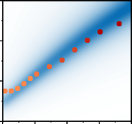

Im *R*

1.18

*S*1/*Sh*-BN

0.89

(d)

plasmon

Strong *γ*i

*e e-h* pair generati

*h*

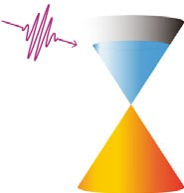

(e)

*e*

on

plasmon

*h*

Weak *γ*i

100

*ћω* (meV)

50

0

Acoustic mode

intraband Landau damping

0.0

(c) 0.20

0.15

0.10

*γ*

0.05

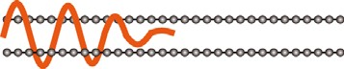0.00

*n*b (1012 cm-2)

(f)

(h)

*γ*n + *γ*i

*γ*n

*γ*i

*ћω* (meV)

140

120

0 20 40 60 80

*q* (*μ*m-1)

5.5

0.5



*n*b≈ 0

Im *R*

OFF

(g)

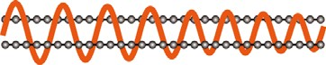(i)

*ћω* (meV)

140

120

0

20 40 60 80

*q* (*μ*m-1)

5.5

0.5



*n*b = -*n*t

Im *R*

ON

0 50 100

*q* (*μ*m-1)

0 4 8 12 16

*n*b (1012 cm-2) Low *E*F of bottom layer High *E*F of bottom layer

FIG. 3. Dispersions and damping of the coupled plasmon. (a) The calculated dispersion of the coupled plasmon with interlayer spacing *d* 6.8 nm and *nb* −*nt* 9.8 × 1012 cm−2. The blue color plots show the imaginary part of the Fresnel reflection coefficient (see Supplemental Material [25]). The calculated dispersion of the single-layer graphene plasmon (black line) is also provided for comparison (*ns* −9.8 × 1012 cm−2). The red dashed line marks the excited photon energy of 115.9 meV. The orange shaded regions indicate the *h*-BN phonon bands. (b) Experimental (red dots) and theoretical (blue color plots) carrier density dependence of plasmon wavelength and intensity. The color depth of the red dots and blue color plots represents the plasmon intensity. (c) Experimental (black dots) carrier density dependence of the damping rate. The theoretical results include the damping rate due to the impurity scattering γ*i* (magenta dashed line), and the damping rate γ*n* (blue dashed line) extracted from the numerical color plots. The red line shows the joint contribution of the two aspects. (d),(e) Illustration of the damping process when the Fermi level of the bottom-layer graphene is near and far away from the Dirac point, respectively. (f), (g) Plasmon dispersions of coupled plasmon for the cases of *nt* ¼ −9.8 × 1012 cm−2, *nb* ≈ 0, and *nb* ¼ −*nt* ¼ 9.8 × 1012 cm−2. (h),(i) Conceptual schematics of the plasmon damping switch.

¼

¼ ¼ ¼

Fig. 4(b) also shows a saturated trend when *d* exceeds 20 nm. The *d* dependence of damping rate is also extracted as shown in Fig. S5 (see Supplemental Material [25]),

(a)

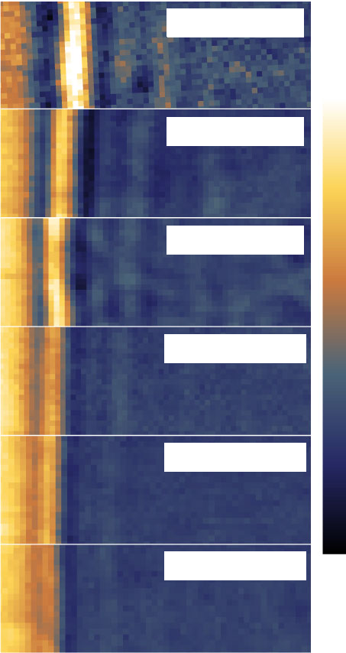

*d* = 3.0 nm

*d* = 5.8 nm

*d* = 6.8 nm

*d* = 10.0 nm

*d* = 15.2 nm

*d* = 19.2 nm

Max

*λ* (nm)

(b)

250

200

150

100

0 5 10 15 20 25 30 ∞

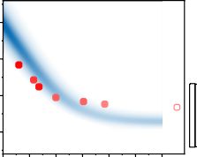

*d* (nm)

3.55

0.35

Im *R*

1.02

*S*1/*Sh*-BN

0.77

*S*/*Sh*-BN

which shows minimal change. Moreover, we carried out systematic studies of simultaneously varied carrier density and *d* as shown in Fig. 4(c). Benefitting from the additional control parameter *d*, a much wider tuning range in the double-layer system is achieved than that of single-layer graphene.

In summary, we demonstrate systematical tunability of coupled plasmon in different aspects, including wave-

Min

1. 18

16

14

*d* (nm)

12

10

8

6

4

6 8 10 12 14

*n*b*= -n*t (1012 cm-2)

245

122

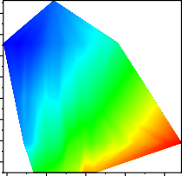

*λ*c (nm)

length, intensity, and damping rate, by changing the carrier density and interlayer spacing. In particular, we realize the active control of the damping rate by introducing an external damping amplifier, which results from the unique linear gapless energy dispersion of graphene. Our study provides in-depth understanding of the coupled plasmon and highlights the rich regulatory advantages of the double- layer graphene system. The proposed plasmon damping

FIG. 4. Interlayer spacing dependence of the coupled plasmon mode. (a) Near-field images and corresponding line profiles of coupled plasmons for different interlayer spacing *d* (*nb* −*nt*≈

¼

* 1. × 1012 cm−2 for all devices). Scale bar, 200 nm. (b) Experi- mental (red dots) and theoretical (blue color plots) *d* of the wavelength and intensity. The color depth of red dots and blue color plots represents the plasmon intensity. The red circle shows the plasmon wavelength of single-layer graphene when *ns*≈

−8.5 × 1012 cm−2. (c) Variation in coupled plasmon wavelength when carrier density and *d* simultaneously change.

switch gives rise to a new thought for the development of nanophoto devices. And the concept of external damping modulator could also be popularized in other quasiparticle systems.

This work was supported by the National Natural Science Foundation of China (Grants No. 92165201, No. 11974324, No. 12274301, No. 12104435, and

No. 11874268), the Innovation Program for Quantum Science and Technology (Grant No. 2021ZD0302800),

the CAS Project for Young Scientists in Basic Research (Grant No. YSBR-046), Strategic Priority Research Program of Chinese Academy of Sciences (Grant No. XDC07010000), the Anhui Initiative in Quantum Information Technologies (Grant No. AHY170000), the Hefei Science Center CAS (Grant No. 2020HSC-UE014), and the Fundamental Research Funds for the Central Universities (Grant No. WK3510000013). Part of this work was carried out at the USTC Center for Micro and Nanoscale Research and Fabrication.



*Corresponding author. [fanxd@ustc.edu.cn](mailto:fanxd@ustc.edu.cn)

†Corresponding author. [xgli@szu.edu.cn](mailto:xgli@szu.edu.cn)

‡Corresponding author. [cgzeng@ustc.edu.cn](mailto:cgzeng@ustc.edu.cn)

¶These authors contributed equally to this work.

* + 1. A. Boltasseva and H. A. Atwater, Low-loss plasmonic metamaterials, [Science 331, 290 (2011)](https://doi.org/10.1126/science.1198258).
    2. M. I. Aslam and D. Ö. Güney, Surface plasmon driven scalable low-loss negative-index metamaterial in the visible spectrum, [Phys. Rev. B 84, 195465 (2011)](https://doi.org/10.1103/PhysRevB.84.195465).
    3. J. I. A. Li, T. Taniguchi, K. Watanabe, J. Hone, and C. R. Dean, Excitonic superfluid phase in double bilayer gra- phene, [Nat. Phys. 13, 751 (2017)](https://doi.org/10.1038/nphys4140).
    4. X. Liu, K. Watanabe, T. Taniguchi, B. I. Halperin, and P. Kim, Quantum Hall drag of exciton condensate in graphene, [Nat. Phys. 13, 746 (2017)](https://doi.org/10.1038/nphys4116).
    5. G. S. MacCabe, H. Ren, J. Luo, J. D. Cohen, H. Zhou, A. Sipahigil, M. Mirhosseini, and O. Painter, Nano-acoustic resonator with ultralong phonon lifetime, [Science 370, 840](https://doi.org/10.1126/science.abc7312) [(2020)](https://doi.org/10.1126/science.abc7312).
    6. J. Cuffe, O. Ristow, E. Chávez, A. Shchepetov, P.-O. Chapuis, F. Alzina, M. Hettich, M. Prunnila, J. Ahopelto,

T. Dekorsy, and C. M. Sotomayor Torres, Lifetimes of Confined Acoustic Phonons in Ultrathin Silicon Membranes, [Phys. Rev. Lett. 110, 095503 (2013)](https://doi.org/10.1103/PhysRevLett.110.095503).

* + 1. H. Yan, T. Low, W. Zhu, Y. Wu, M. Freitag, X. Li, F. Guinea, P. Avouris, and F. Xia, Damping pathways of mid- infrared plasmons in graphene nanostructures, [Nat. Photon-](https://doi.org/10.1038/nphoton.2013.57) [ics 7, 394 (2013)](https://doi.org/10.1038/nphoton.2013.57).
    2. P. Rivera, J. R. Schaibley, A. M. Jones, J. S. Ross, S. Wu, G. Aivazian, P. Klement, K. Seyler, G. Clark, N. J. Ghimire, J. Yan, D. G. Mandrus, W. Yao, and X. Xu, Observation of long-lived interlayer excitons in monolayer MoSe2-WSe2 heterostructures, [Nat. Commun. 6, 6242 (2015)](https://doi.org/10.1038/ncomms7242).
    3. W. Ma, P. Alonso-González, S. Li, A. Y. Nikitin, J. Yuan, J. Martín-Sánchez, J. Taboada-Gutie´rrez, I. Amenabar, P. Li,

S. Ve´lez, C. Tollan, Z. Dai, Y. Zhang, S. Sriram, K. Kalantar-Zadeh, S.-T. Lee, R. Hillenbrand, and Q. Bao, In-plane anisotropic and ultra-low-loss polaritons in a natural van der Waals crystal, [Nature (London) 562, 557](https://doi.org/10.1038/s41586-018-0618-9) [(2018)](https://doi.org/10.1038/s41586-018-0618-9).

* + 1. K. Sadhukhan, A. Politano, and A. Agarwal, Novel Un- damped Gapless Plasmon Mode in a Tilted Type-II Dirac Semimetal, [Phys. Rev. Lett. 124, 046803 (2020)](https://doi.org/10.1103/PhysRevLett.124.046803).
    2. G. X. Ni, A. S. McLeod, Z. Sun, L. Wang, L. Xiong,

K. W. Post, S. S. Sunku, B.-Y. Jiang, J. Hone, C. R. Dean, M. M. Fogler, and D. N. Basov, Fundamental limits to graphene plasmonics, [Nature (London) 557, 530](https://doi.org/10.1038/s41586-018-0136-9) [(2018)](https://doi.org/10.1038/s41586-018-0136-9).

* + 1. A. N. Grigorenko, M. Polini, and K. S. Novoselov, Graphene plasmonics, [Nat. Photonics 6, 749 (2012)](https://doi.org/10.1038/nphoton.2012.262).
    2. T. Low and P. Avouris, Graphene plasmonics for tera- hertz to mid-infrared applications, [ACS Nano 8, 1086](https://doi.org/10.1021/nn406627u) [(2014)](https://doi.org/10.1021/nn406627u).
    3. S. Huang, C. Song, G. Zhang, and H. Yan, Graphene plasmonics: Physics and potential applications, [Nano-](https://doi.org/10.1515/nanoph-2016-0126) [photonics 6, 1191 (2017)](https://doi.org/10.1515/nanoph-2016-0126).
    4. Z. Fei, A. S. Rodin, G. O. Andreev, W. Bao, A. S. McLeod,

M. Wagner, L. M. Zhang, Z. Zhao, M. Thiemens, G. Dominguez, M. M. Fogler, A. H. C. Neto, C. N. Lau, F. Keilmann, and D. N. Basov, Gate-tuning of graphene plasmons revealed by infrared nano-imaging, [Nature](https://doi.org/10.1038/nature11253) [(London) 487, 82 (2012)](https://doi.org/10.1038/nature11253).

* + 1. J. Chen, M. Badioli, P. Alonso-González, S. Thongrattanasiri, F. Huth, J. Osmond, M. Spasenović, A. Centeno, A. Pesquera, P. Godignon, A. Z. Elorza, N. Camara, F. J. G. de Abajo, R. Hillenbrand, and F. H. L. Koppens, Optical nano-imaging of gate-tunable graphene plasmons, [Nature (London) 487, 77 (2012)](https://doi.org/10.1038/nature11254).
    2. L. Ju, B. Geng, J. Horng, C. Girit, M. Martin, Z. Hao, H. A. Bechtel, X. Liang, A. Zettl, Y. R. Shen, and F. Wang, Graphene plasmonics for tunable terahertz metamaterials, [Nat. Nanotechnol. 6, 630 (2011)](https://doi.org/10.1038/nnano.2011.146).
    3. A. Woessner, M. B. Lundeberg, Y. Gao, A. Principi, P. Alonso-González, M. Carrega, K. Watanabe, T. Taniguchi,

G. Vignale, M. Polini, J. Hone, R. Hillenbrand, and

F. H. L. Koppens, Highly confined low-loss plasmons in graphene–boron nitride heterostructures, [Nat. Mater. 14,](https://doi.org/10.1038/nmat4169) [421 (2015)](https://doi.org/10.1038/nmat4169).

* + 1. H. Hu, R. Yu, H. Teng, D. Hu, N. Chen, Y. Qu, X. Yang,

X. Chen, A. S. McLeod, P. Alonso-González, X. Guo, C. Li,

Z. Yao, Z. Li, J. Chen, Z. Sun, M. Liu, F. J. G. de Abajo, and Q. Dai, Active control of micrometer plasmon propa- gation in suspended graphene, [Nat. Commun. 13, 1465](https://doi.org/10.1038/s41467-022-28786-8) [(2022)](https://doi.org/10.1038/s41467-022-28786-8).

* + 1. X. Yang, F. Zhai, H. Hu, D. Hu, R. Liu, S. Zhang, M. Sun, Z. Sun, J. Chen, and Q. Dai, Far-field spectroscopy and near- field optical imaging of coupled plasmon–phonon polari- tons in 2D van der Waals heterostructures, [Adv. Mater. 28,](https://doi.org/10.1002/adma.201505765) [2931 (2016)](https://doi.org/10.1002/adma.201505765).
    2. G. X. Ni, H. Wang, J. S. Wu, Z. Fei, M. D. Goldflam, F. Keilmann, B. Özyilmaz, A. H. Castro Neto, X. M. Xie,

M. M. Fogler, and D. N. Basov, Plasmons in graphene moire´ superlattices, [Nat. Mater. 14, 1217 (2015)](https://doi.org/10.1038/nmat4425).

* + 1. E. H. Hwang and S. D. Sarma, Plasmon modes of spatially separated double-layer graphene, [Phys. Rev. B 80, 205405](https://doi.org/10.1103/PhysRevB.80.205405) [(2009)](https://doi.org/10.1103/PhysRevB.80.205405).
    2. T. Stauber and G. Gómez-Santos, Plasmons and near-field amplification in double-layer graphene, [Phys. Rev. B 85,](https://doi.org/10.1103/PhysRevB.85.075410) [075410 (2012)](https://doi.org/10.1103/PhysRevB.85.075410).
    3. R. E. V. Profumo, R. Asgari, M. Polini, and A. H. MacDonald, Double-layer graphene and topological insu- lator thin-film plasmons, [Phys. Rev. B 85, 085443](https://doi.org/10.1103/PhysRevB.85.085443) [(2012)](https://doi.org/10.1103/PhysRevB.85.085443).
    4. See Supplemental Material at [http://link.aps.org/](http://link.aps.org/supplemental/10.1103/PhysRevLett.129.237402) [supplemental/10.1103/PhysRevLett.129.237402](http://link.aps.org/supplemental/10.1103/PhysRevLett.129.237402) for experi- mental and theoretical details, as well as additional figures and discussions, which includes Refs. [15,16,18,22,24,26–36].
    5. S.-J. Ding, X. Li, F. Nan, Y.-T. Zhong, L. Zhou, X. Xiao, Q.-Q. Wang, and Z. Zhang, Strongly Asymmetric Spectroscopy in Plasmon-Exciton Hybrid Systems due to Interference-Induced Energy Repartitioning, [Phys. Rev.](https://doi.org/10.1103/PhysRevLett.119.177401) [Lett. 119, 177401 (2017)](https://doi.org/10.1103/PhysRevLett.119.177401).
    6. X. Li, L. Zhou, Z. Hao, and Q.-Q. Wang, Plasmon–exciton coupling in complex systems, [Adv. Opt. Mater. 6, 1800275](https://doi.org/10.1002/adom.201800275) [(2018)](https://doi.org/10.1002/adom.201800275).
    7. A. Principi, G. Vignale, M. Carrega, and M. Polini, Impact of disorder on Dirac plasmon losses, [Phys. Rev. B 88,](https://doi.org/10.1103/PhysRevB.88.121405) [121405(R) (2013)](https://doi.org/10.1103/PhysRevB.88.121405).
    8. L. Wang, I. Meric, P. Y. Huang, Q. Gao, Y. Gao, H. Tran, T. Taniguchi, K. Watanabe, L. M. Campos, D. A. Muller, J. Guo, P. Kim, J. Hone, K. L. Shepard, and C. R. Dean, One- dimensional electrical contact to a two-dimensional material, [Science 342, 614 (2013)](https://doi.org/10.1126/science.1244358).
    9. Z. Ni, Y. Wang, T. Yu, and Z. Shen, Raman spectroscopy and imaging of graphene, [Nano Res. 1, 273 (2008)](https://doi.org/10.1007/s12274-008-8036-1).
    10. N. Lindvall, A. Kalabukhov, and A. Yurgens, Cleaning graphene using atomic force microscope, [J. Appl. Phys.](https://doi.org/10.1063/1.3695451) [111, 064904 (2012)](https://doi.org/10.1063/1.3695451).
    11. N. Ocelic, A. Huber, and R. Hillenbrand, Pseudoheterodyne detection for background-free near-field spectroscopy, [Appl. Phys. Lett. 89, 101124 (2006)](https://doi.org/10.1063/1.2348781).
    12. Y. Cai, L. Zhang, Q. Zeng, L. Cheng, and Y. Xu, Infrared reflectance spectrum of BN calculated from first principles, [Solid State Commun. 141, 262 (2007)](https://doi.org/10.1016/j.ssc.2006.10.040).
    13. J. D. Caldwell, A. V. Kretinin, Y. Chen, V. Giannini, M. M. Fogler, Y. Francescato, C. T. Ellis, J. G. Tischler, C. R. Woods, A. J. Giles, M. Hong, K. Watanabe, T. Taniguchi,

S. A. Maier, and K. S. Novoselov, Sub-diffractional volume- confined polaritons in the natural hyperbolic material hexagonal boron nitride, [Nat. Commun. 5, 5221](https://doi.org/10.1038/ncomms6221) [(2014)](https://doi.org/10.1038/ncomms6221).

* + 1. A. Principi, M. Carrega, M. B. Lundeberg, A. Woessner,

F. H. L. Koppens, G. Vignale, and M. Polini, Plasmon losses due to electron-phonon scattering: The case of graphene encapsulated in hexagonal boron nitride, [Phys. Rev. B 90,](https://doi.org/10.1103/PhysRevB.90.165408) [165408 (2014)](https://doi.org/10.1103/PhysRevB.90.165408).

* + 1. A. Principi, G. Vignale, M. Carrega, and M. Polini, Intrinsic lifetime of Dirac plasmons in graphene, [Phys. Rev. B 88,](https://doi.org/10.1103/PhysRevB.88.195405) [195405 (2013)](https://doi.org/10.1103/PhysRevB.88.195405).
    2. X. Li, A. Teng, M. M. Özer, J. Shen, H. H. Weitering, and Z. Zhang, Plasmonic excitations in ultrathin metal films on dielectric substrates, [New J. Phys. 16, 065014](https://doi.org/10.1088/1367-2630/16/6/065014) [(2014)](https://doi.org/10.1088/1367-2630/16/6/065014).
    3. S. Dai, Q. Ma, M. K. Liu, T. Andersen, Z. Fei, M. D. Goldflam, M. Wagner, K. Watanabe, T. Taniguchi, M. Thiemens, F. Keilmann, G. C. A. M. Janssen, S.-E. Zhu,

P. Jarillo-Herrero, M. M. Fogler, and D. N. Basov, Graphene on hexagonal boron nitride as a tunable hyperbolic meta- material, [Nat. Nanotechnol. 10, 682 (2015)](https://doi.org/10.1038/nnano.2015.131).